Issue 24 – December 2023

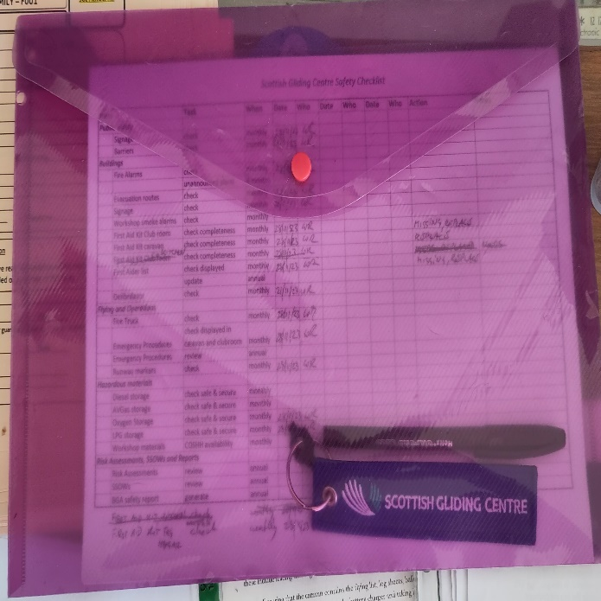
To begin I want to welcome Lachlan Sloan in the new role of deputy safety officer. He will bring a new perspective to safety and help with anything safety related. Anything safety related you wish to discuss please contact either myself or Lachlan.
However, there are many tasks to be done on a regular basis to check a variety of items. This has been neglected during Covid but is now restarted and anyone can help with this. A sheet with tasks to be performed regularly (most of them monthly) is in the purple folder on the table in the clubroom (where all the other forms are). Anyone can have a look and if there are checks due, and you have some spare time, please do them. Most of these are just checking that everything is still in order. If you have any questions about this, please contact myself or Lachlan.

From the BGA
During a recent review of technical-related occurrence reports, it was identified that Puchacz and Perkoz canopy locking mechanisms appear to be causing issues that result in the canopy not being locked correctly before flight.
As ever, canopy locking mechanisms need careful inspection and maintenance. And great care is needed during the pre-flight checks to ensure the canopies are down, locked, and do not open with upward pressure.
The BGA's safety and technical committees are very interested in hearing about any technical or operational occurrences relating to canopy locking mechanisms on any gliders, including the two types noted above. So please report any issues with canopy locking mechanisms via Flysafe so we can report to the BGA.
A JS3 departed from controlled flight during a winch launch. The pilot was seriously injured. The BGA investigation report has been published at https://members.gliding.co.uk/library/investigation-reports/jonker-js3-accident-report-june-2023/.
The report details two recommendations:
- Remind pilots of the hazard of being forced rearwards during acceleration on a winch launch and highlight the need for the pilot to be adequately restrained during this phase of flight. We believe this important point is also relevant to maintenance - checking seat and seat back mountings and restraints is an important part of an annual inspection.
- Noting that the BGA’s safe launching initiative has had a marked effect on accident rates, the second recommendation is that the BGA should continue to bring this material to the attention of BGA clubs and their members.

Trailers
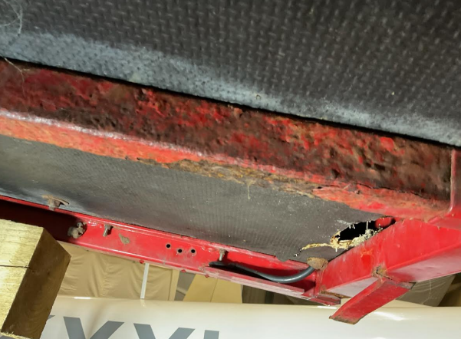
The Grob trailer – which was loaned to Staffordshire club and is now at Edgehill to see if the DG505 would fit in it - turns out to be seriously corroded and a similar one at another club did fail in use. It will need repaired - to fix the substantial cracks, and the severe rusting and corrosion to the steel box section. The picture shows just one issue of many.
Regular inspections of trailer, especially older ones, seems like a really good idea. There is no legal requirement for an MOT test or similar in the UK but you could be prosecuted if you use a trailer that is not roadworthy and cause an accident as a result.

A safety lesson from the past
Thanks to David Dodds for the following article:
In October 1950 Allan Pratt, Slingsby’s test pilot was carrying out tests on an experimental Slingsby Prefect Mk II at Sutton bank when his third flight went badly wrong. Allan’s logbook tersely records what happened.
“Cable and weak link caught on wheel on take-off – stick full forward on launch – vertical climb. Winch throttled back at top of launch – fell into stall turn to right – cable tightened – airspeed increased – winch driver hauling cable in. Dive to slacken cable – pull up and attempt to snap. Below edge (the edge of the hill) – couldn’t turn. Decreased airspeed to 45mph – cable tightened – aircraft dived – cable snapped – 250 feet below edge of hill, scraped to top. 400 feet above edge – approach centre of field and land – 200 feet dangling.”
What relevance does a near accident in Yorkshire from over 70 years ago have for us today? After all, in that post-war period flight safety was a much more limited concept than it is today. The answer to this lies in the circumstances on the airfield at the time and the causes of the accident noted by Allan in his logbook:
- “Bad SIGNAL SYSTEM.
- INSUFFICIENT ground crew.
- No AXE on winch.”
This was a weekday and the ground crew and winch driver were not gliding club members but are thought to have been a scratch crew comprising staff from the Slingsby factory nearby and probably not fully conversant with what was required to safely launch a glider.
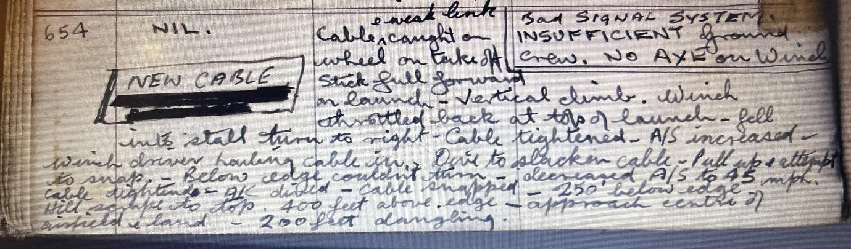
At this time of year, when fewer people brave the cold and come flying this is a useful reminder for us: when we are short-handed and trying to get flying it’s very tempting to cut corners, it’s easy to miss things and tempting to take on tasks we aren’t fully conversant with, all with the very best of intentions.
Allan’s logbook entry
Happily, winch-drivers no longer need to check they have an axe in the winch as part of their start of day checks, but Allan’s day would have been much less “exciting” if the winch-driver had been equipped to cut the cable at his end and if the ground crew had been suitably experienced and briefed and properly equipped to communicate with the winch.

Batteries in Winter
After a long cold spell, your batteries may loose some of their capacity. The club has a battery tester, so you can check the capacity of your battery, rather than discover on your next cross country flight that your battery doesn’t last very long any more.
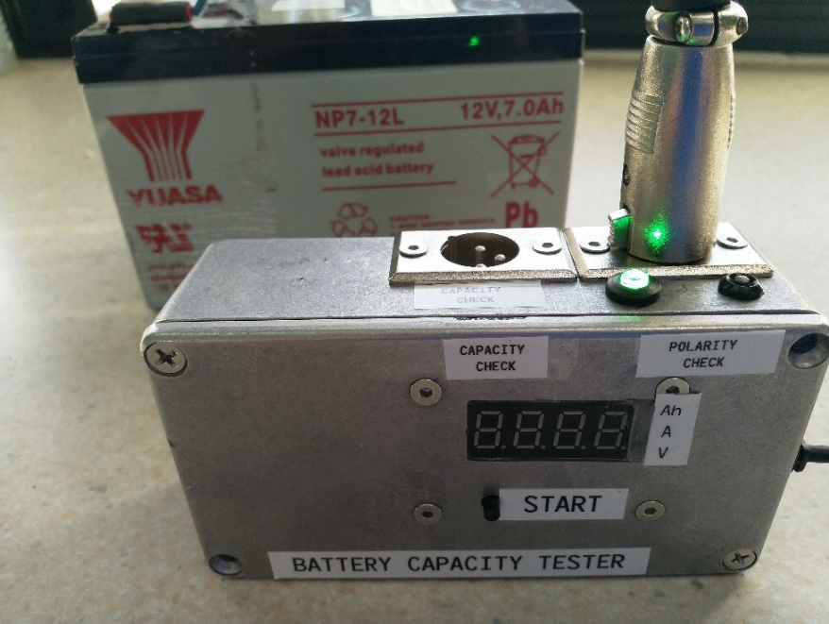
The device has two built in connectors for the standard 3 pin XLR connector widely used in the club with Pin 2 being -ve and Pin 1 being +ve. The first connector provides a Polarity Check function to confirm that the XLR connector is wired to the correct polarity and should be used before connecting the battery to the Capacity Check XLR connector. A lead with Crocodile clips is available for batteries which do not have the 3 pin XLR connector. Please use the polarity checker before connecting for a capacity test.
Green light indicates correct XLR polarity, a flashing Red light warns of reversed XLR connector polarity.
Once connected to the Capacity Check connector the display will show battery voltage.
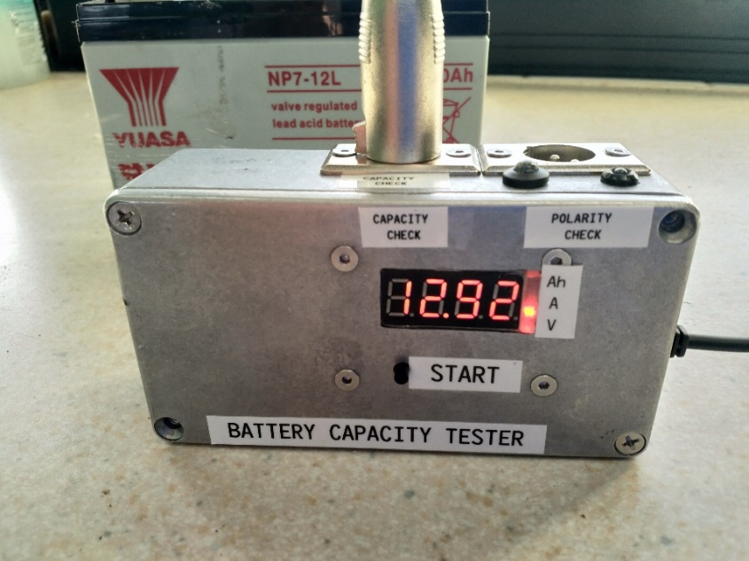
Pressing the START button will commence a test cycle. During the cycle the display will rotate through Ampere hours (Ah), Amps (A) and Volts (V) values. When the Capacity Check is complete it will display only the Ah capacity of the battery.
Note that a Capacity Check on a full capacity 7Ah battery will take around 17 hours and for the larger 10Ah battery around 24 hours.

Merry Christmas and a Happy New Year

